Corner House Residents Newsletter 2018

Welcome to your November Newsletter

Interesting Facts for November
1956 The Wizard of Oz was first shown on TV. Now recognised as the most watched film in TV History.
1605 – The Gunpowder Plot. An attempt was made to blow up Parliament. The Plots leader Guy Fawkes was caught with 36 barrels of gunpowder at the House of Lords, He was tortured and executed.
1989 – Fall of the Berlin Wall.
Crowds of East Germans crossed and climbed onto the Wall, joined by West Germans on the other side in a celebratory atmosphere.

Announcements
We would like to welcome back Tracy Josko will be returning from maternity leave and is coming back to work part time starting in November. Tracy will be working in the administration office with Gordon.
Welcome to Holli & Molly who are starting as apprentices this month and we would also like to welcome Nathan a college student, who will be with us over the next 6 weeks for work experience.
Valuables
Just a reminder that all cash and valuables kept in Resident’s rooms or on their person, are the responsibility of the Resident. We have a safe available to keep cash and valuables in. If you have any valuables in your room that you would like kept in the safe. Please come to the office and see Gordon, who can lock these away for safe keeping for you.

Building Work
The new shower upstairs has been completed and is now in use, work continues on the communal bathroom upstairs. The Retro Lounge upstairs is in the process of a makeover and the small Lounge downstairs will be a new Bar area called The Temple Bar.
All building works should be completed by the end of November.
Choir Practice
We are still looking for a name for our Choir, also for volunteers to join in. Look for sessions in the Café in November.
We will need to have a name, perhaps the Corner House Crooners?! Any suggestions to Adina please.

.
Pen Pals in Scotland
We have arranged with another care home in Scotland to set up some Pen Pals. We will be conversing with The Howard Doris Centre in Lochcarron. Which is a pretty village of white-washed cottages on the shore of Loch Carron in the Wester Ross region of Scotland. Those of you who are interested in writing to some people in Scotland, please contact Adina, don’t worry if you don’t feel up to writing the letter yourself, Adina and the Carers will help you. Wouldn’t it be lovely to get a letter from a new friend and find out how life differs from ours in the Highlands of Scotland?
Sing Along Sessions
Adina has been working hard to put together a collection of song sheets and music for us all to sing along with. Please come along to the Karaoke events and we can all join in.
Angel Of The Month
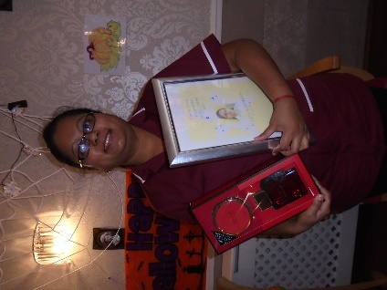
Lata, who head our housekeeping team, has been voted as Angel of the Month for October.
She was nominated for being king & helpful.
Congratulations Lata.

Changes in the Kitchen

Chris the Chef has left after 8 years of service. We would like to welcome our new Chef Sue, who starts on the 5th and thanks go to Martin & Blake who have been helping out until Sue gets started. Not forgetting John who will continue to work with Sue in the kitchen. We are looking forward to tasting her delicious home cooked food.
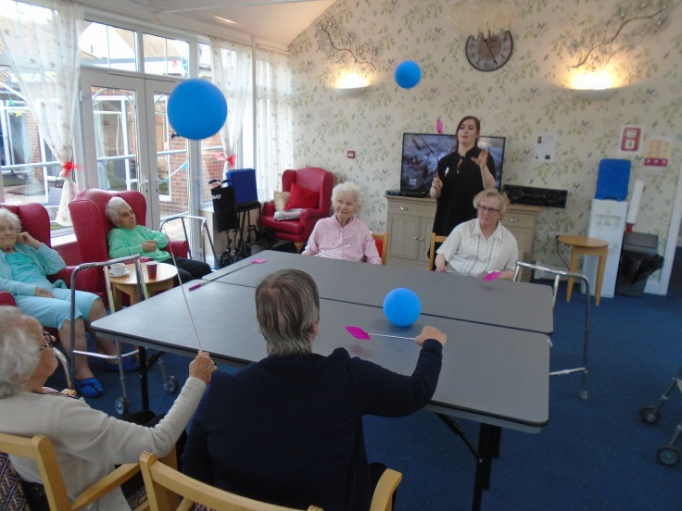
Balloon Table Tennis
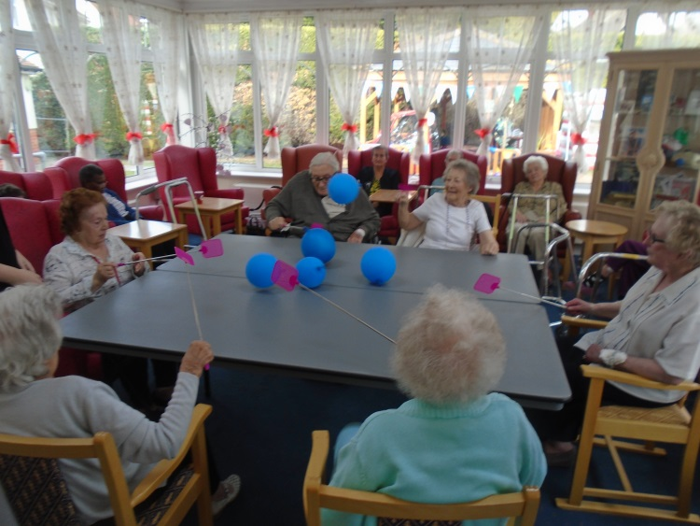This event proved very popular in October as you can see from the pictures.

Arts & Crafts
We had some busy ladies making decorative pebbles, which are now decorating our flower pots at the entrance.
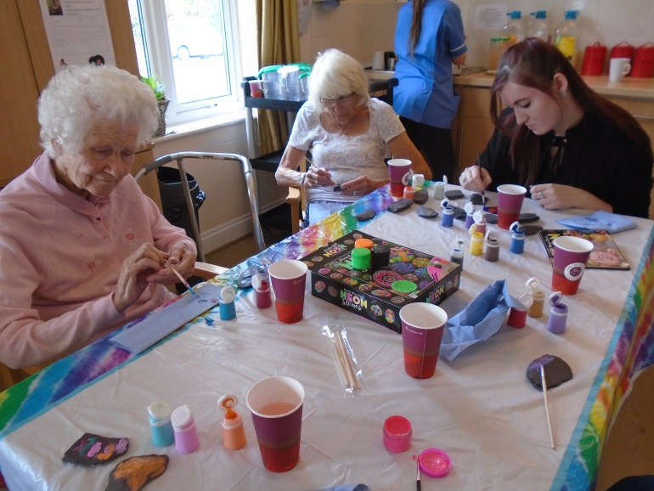
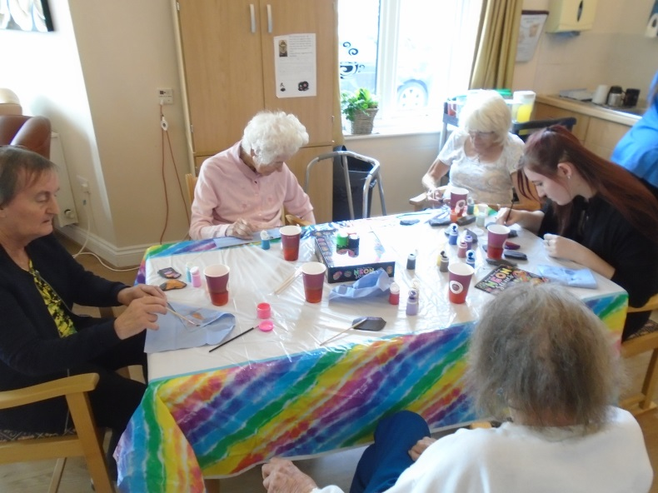
Residents Meeting 23rd October 2018

We discussed the activities over the next 2 months. If anyone has any requests or would like to change anything, please let Adina know. There are plans to visit Tesco twice over the next month, visits will be on the 12th & 26th November. Please let Adina know if you wish to go along. Building work in the home due to be completed by the end of December.

There will be a Bonfire Night party complete with fireworks on the 5th November.

We plan to have heating in the garden Gazebo so people can still go outside to enjoy the fresh air. You will see in the garden the “Beach Hut”, where we will be serving hot drinks, such as Tea, Coffee & Hot Chocolate.

Plans to have a raffle on a monthly basis.

Next Residents meeting is on the 20th November and next Food Group meeting is on 27th November.

Fun with Dominoes
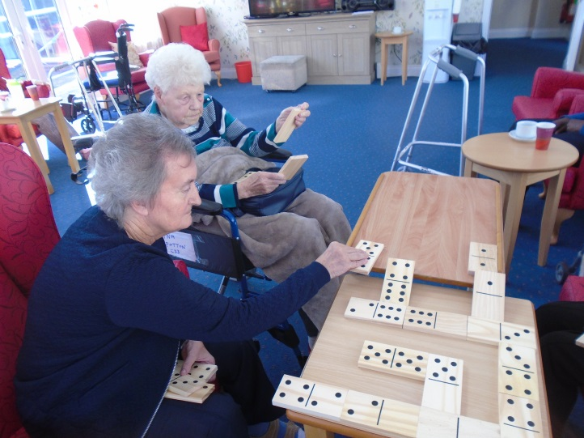
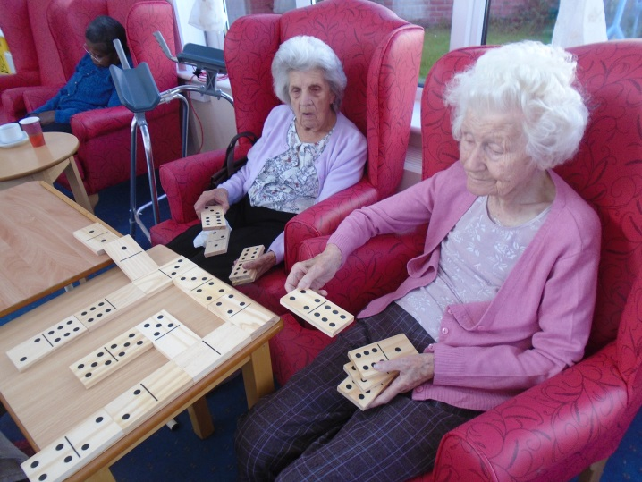

Special congratulations to Eileen,

who Celebrated her 106th Birthday last month.

Eileen holds the record as our oldest resident
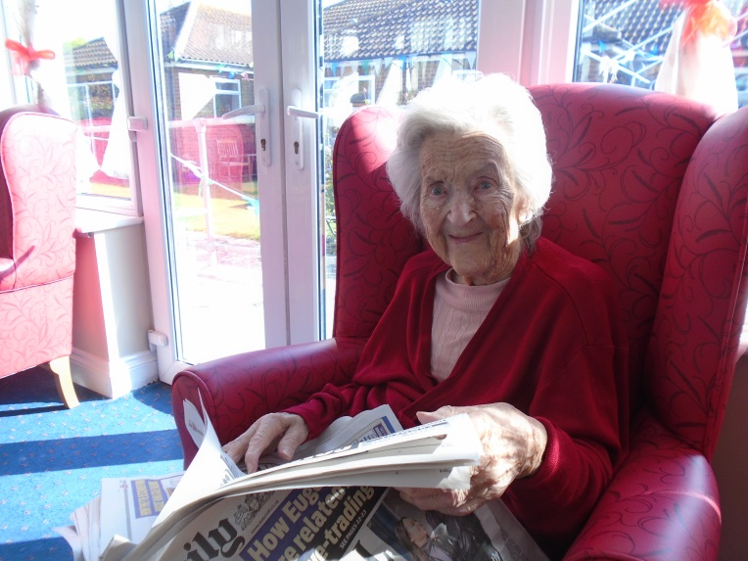

To those celebrating birthdays in November
6th Dennis
17th Mary
19th Ina
25th Barbara
