Corner House Care Ltd
The Bric-a-Brac Newsletter

00000000000000000000000000000000000000000000000000000000000000000000000000000000000000000000000000000000000000000000000000000000000000000000000000000000000000000000000000000000

CQC “Outstanding” in Well Led
67-69 Wash Lane, Clacton, Essex, CO15 1DB
T: 01255 432415 / 222093 F: 01255 474120

-

Welcome all to our September newsletter!

We know it has been a difficult time over the last few months, not being able to see our friends and families.
We have been following government guidance and hope that things will be back to normal soon.
We are thrilled to announce that we have a temporary activities coordinator joining our team! She will be doing lots of fun activities with you all over the coming weeks and as always we have our lovely care staff looking after you always!
Corner House Ltd

September 2020 issue

Riddle of the month

What has a head, a tail, is brown and has no legs?

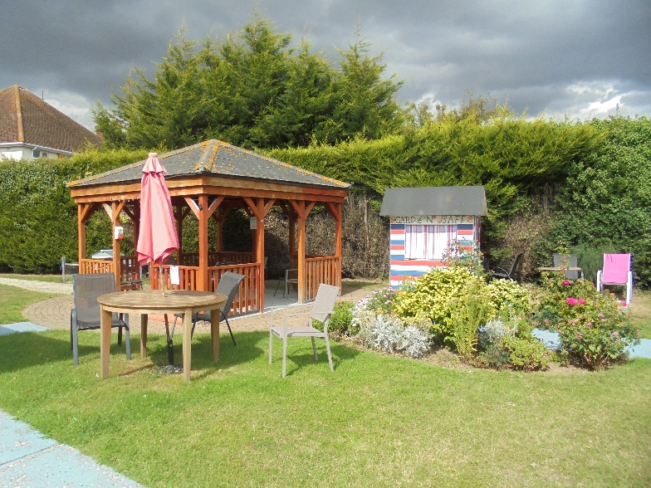
Visiting Arrangements
We have begun to ease restrictions on visitations.
We are now booking appointments with families;
10am – 12pm | 2 visits (1 visitor per resident)
2pm -5pm | 2 visits (2 visits)
6pm – 7pm | 1 visit
however, it must only be one visitor at a time, and the same family member must visit on each occasion.

To keep our lovely residents and staff safe, visits will take place in our gorgeous garden,
In the event of poor weather, visits will take
place in the bar area or front dining area.
All visitors must wear masks and adhere to the 2m social distancing requirement. We will be providing hand sanitization facilities in the garden.
To book a visit please contact us on 01255 222 093 /432415

Visiting times

August Birthdays - Residents
Evelyn 2nd

Ursula & Jean11th
Barbara 8th

Did you know that Gladiolus & Poppy are August birth flowers?
John 31st
Dennis 10th
Arthur 21st
Irene 9th

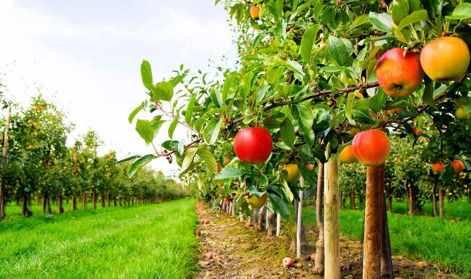
Poem of the month
The golden-rod is yellow;
The corn is turning brown;
The trees in apple orchards
With fruit are bending down.
The gentian’s bluest fringes
Are curling in the sun;
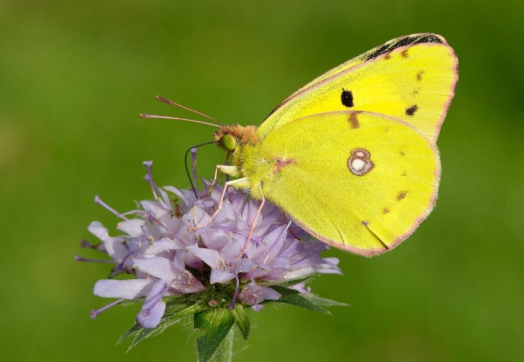
In dusty pods the milkweed
Its hidden silk has spun.
The sedges flaunt their harvest,
In every meadow nook;
And asters by the brook-side
Make asters in the brook.
From dewy lanes at morning
the grapes’ sweet odors rise;
At noon the roads all flutter
With yellow butterflies.
By all these lovely tokens
September days are here,
With summer’s best of weather,
And autumn’s best of cheer.
But none of all this beauty
Which floods the earth and air
Is unto me the secret
Which makes September fair.
‘T is a thing which I remember;
To name it thrills me yet:
One day of one September
I never can forget.
by Helen Marie Hunt Jackson
September Birthdays - Residents

John 28th

Ivy 19th

Did you know that aster is the birth flower of September? It represents love and daintiness and is associated with wisdom, courage and faith.

Kenneth 25th

August & September Birthdays – Staff
Did you know that Sapphire is the birthstone of September?

Ofelia 2nd

Linda 25th

Christine 6th
Lata 24th

Our staff are an integral part of Corner House and they deserve to be celebrated! Thank you for all of your hard work and
Happy birthday on behalf of all staff and residents at Corner House!

Activities

We have been following government guidance over the last few months and therefore we have been limiting contact within the home. However, things are relaxing now, and we are happy to let you all know that the following activities will be taking place over the coming months

- 10-Minute Mobility Workouts
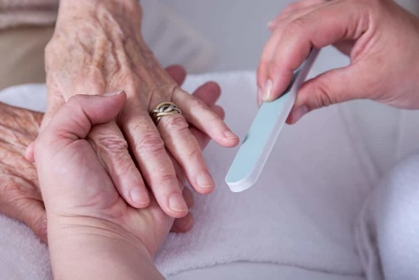
- Cake Decorating
- Balloon Tennis
- Film/quiz nights
- Hand Massages & manicures
- Arts & Crafts
- Blindfolded Tasting
competition
- 1:1 Garden walks
- Flower potting
- Hydration day

And more to come…
This Photo by Unknown Author is licensed under CC BY-SA-NC

Please circle the drinks you enjoy!

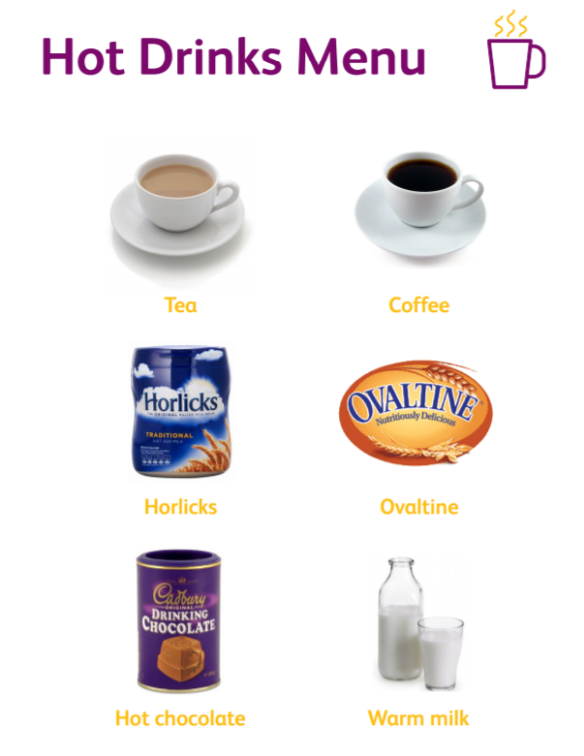
Complete the wordsearch
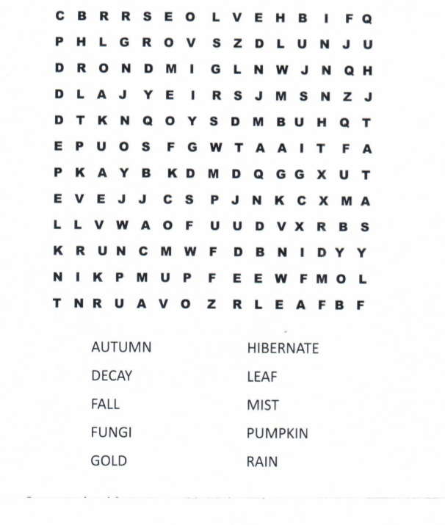
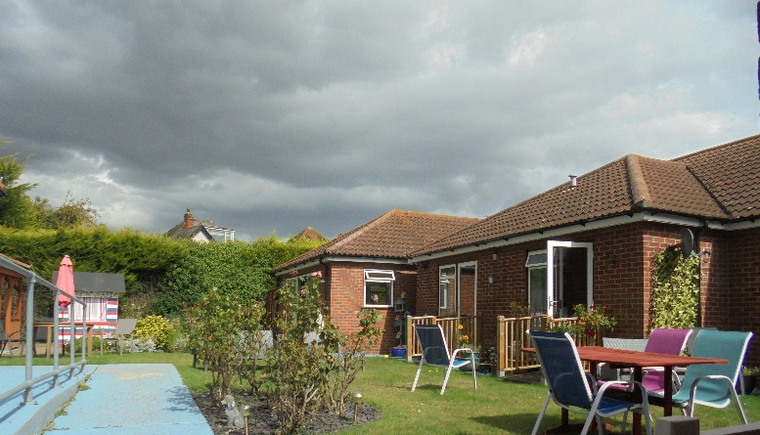
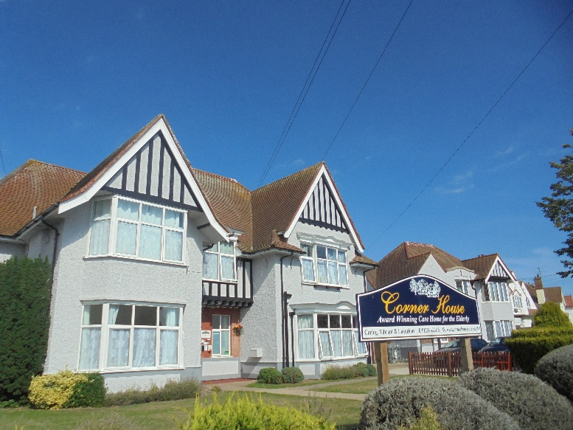
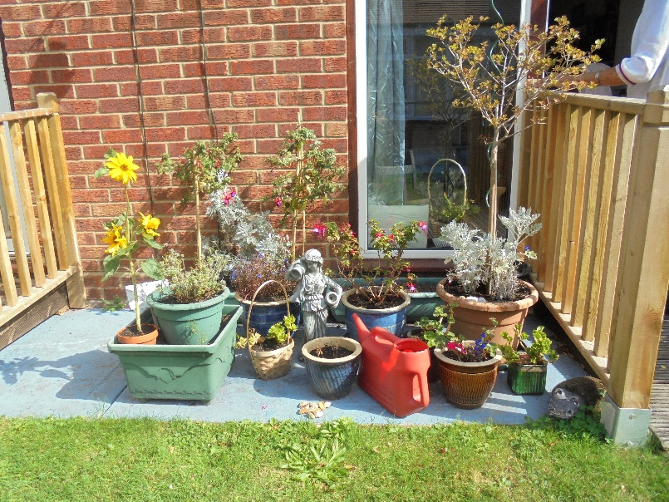
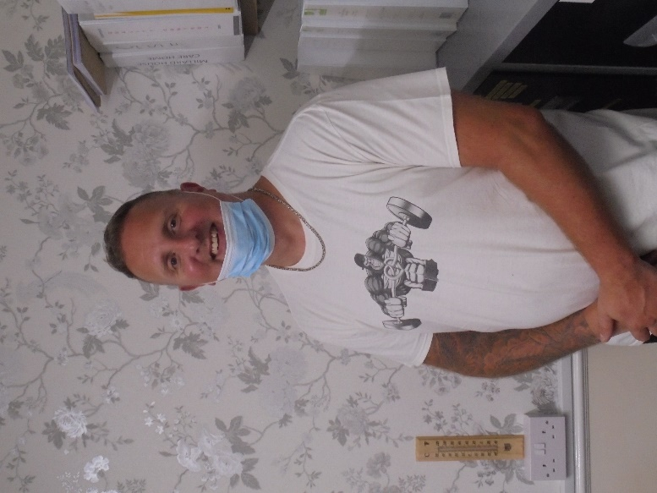
Updates on our home
Here at Corner House we are committed to making sure that our home is in the best condition. We have been carrying out repairs to our house and wanted to share some updates with you all!

Special thanks to our maintenance man - Kevin, who has been working tirelessly to make sure the home is perfect!

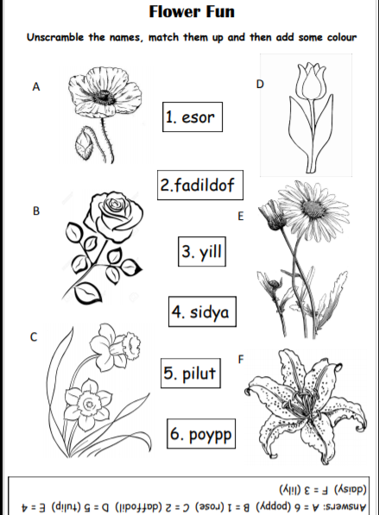
Complete the activity

