

**The Bric-a-Brac Newsletter**

**The Bric-a-Brac Newsletter**



***November Newsletter***

Hello November! We hope you have all been keeping well and safe.

We are excited to share with you, what we have been up to this last month and our plans for the month ahead…

Dates for the Diary:

Sun 1st Nov – All Saints Day

Sun 2nd Nov – All Souls Day  
Thurs 5th Nov – Guy Fawkes Day

Sun 8th Nov – Remembrance Sunday

Sun 29th Nov - First Sunday of Advent   
Mon 30th Nov – St Andrew’s Day

**Riddle of the Month**

You see me once in June, twice in November but not at all in May. What am I?

Answer in next month’s Newsletter



[This Photo](http://leadershipfreak.wordpress.com/2010/05/page/2/) by Unknown Author is licensed under [CC BY](https://creativecommons.org/licenses/by/3.0/)

Remembrance Sunday  
  
On Sunday 8th November at 11am we will be holding a remembrance commemoration of our own. We will observe a two-minute silence in the Sun lounge, all residents are invited to attend so we can remember and honor all those who committed their lives to defending our country.

We will be feeding this live through Zoom so families can join in too. If you would like to attend via zoom please email [admin@cornerhouse.co.uk](mailto:admin@cornerhouse.co.uk) and we will send you the code needed to join.

Corner House would like to take this opportunity to thank all our residents who served in the armed services, working to protect and better our country. A thank you will never quite be enough… we are honored to be able to take care of you and cherish all the sacrifices you have made



October Word Search | Fall words, Halloween words, Halloween word search

**In Flanders Fields**

In Flanders fields the poppies blow  
Between the crosses, row on row,  
That mark our place: and in the sky  
The larks, still bravely singing, fly  
Scarce heard amid the guns below.

We are the Dead. Short days ago  
We lived, felt dawn, saw sunset glow,  
Loved, and were loved, and now we lie  
In Flanders fields.

Take up our quarrel with the foe:  
To you from failing hands we throw  
The torch; be yours to hold it high.  
If ye break faith with us who die  
WE SHALL NOT SLEEP,  
THOUGH POPPIES GROW  
IN FLANDERS FIELDS.  
  
*by John McCrae*

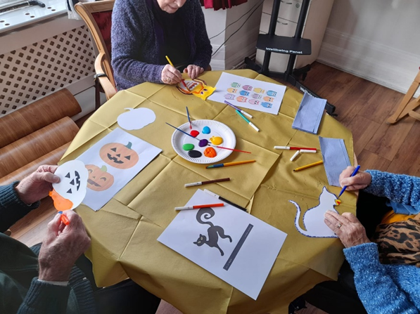**A glimpse of the last month…**

Halloween Arts & Crafts

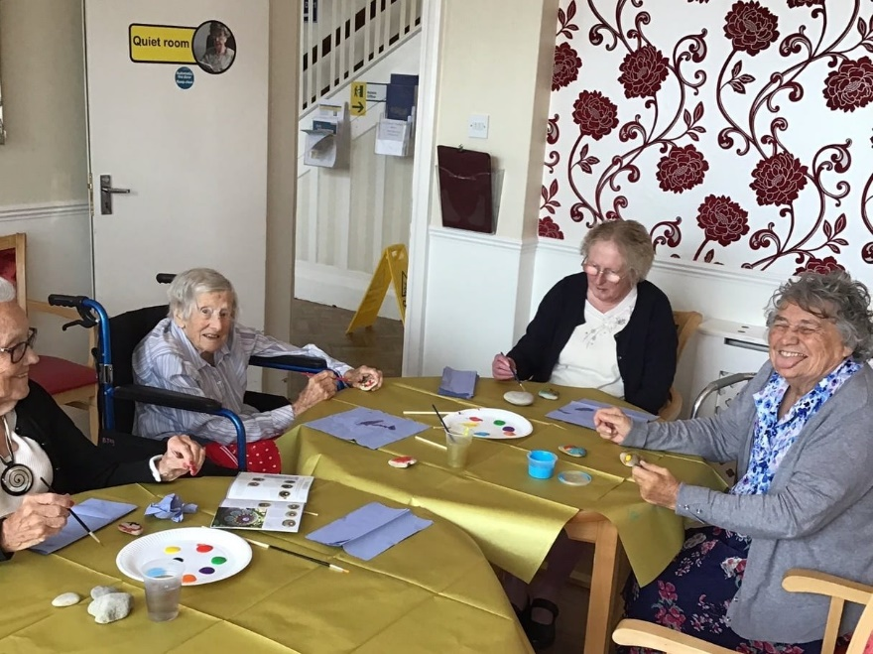

Rock Designing

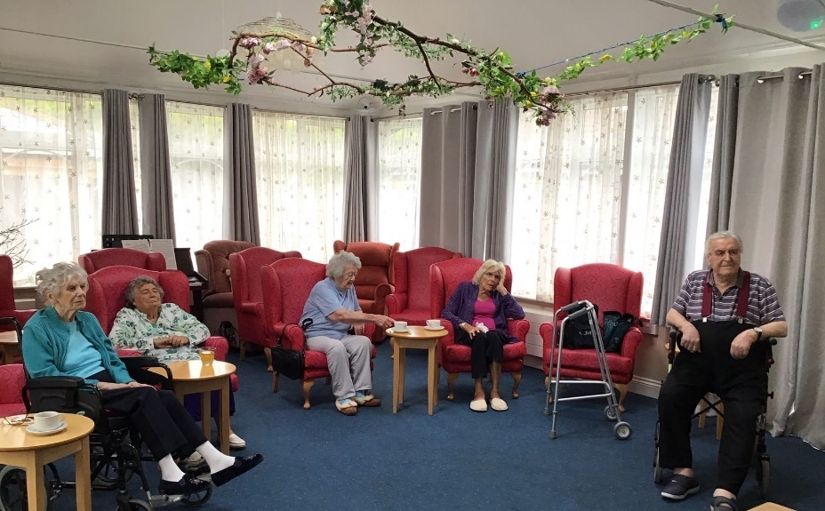

Movie Matinee’s

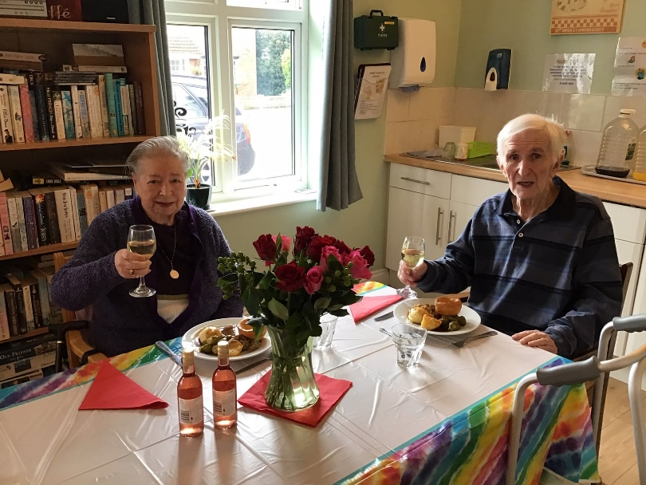

Arthur & Jean’s Ruby Anniversary

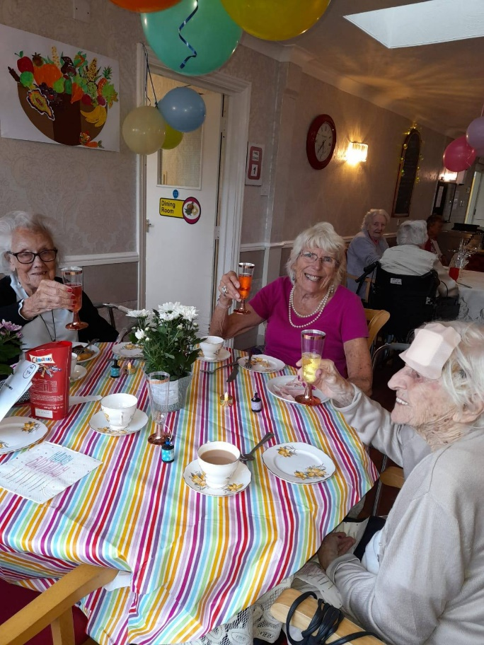

Peggy’s 102nd High Tea Birthday Party

Halloween…

We enjoyed a fantastic Halloween celebration, we held a cookie decorating activity, karaoke and a movie afternoon!

Congratulations to Sharon and Mia for winning best dressed! And thank you to everyone who took part in dressing up!!

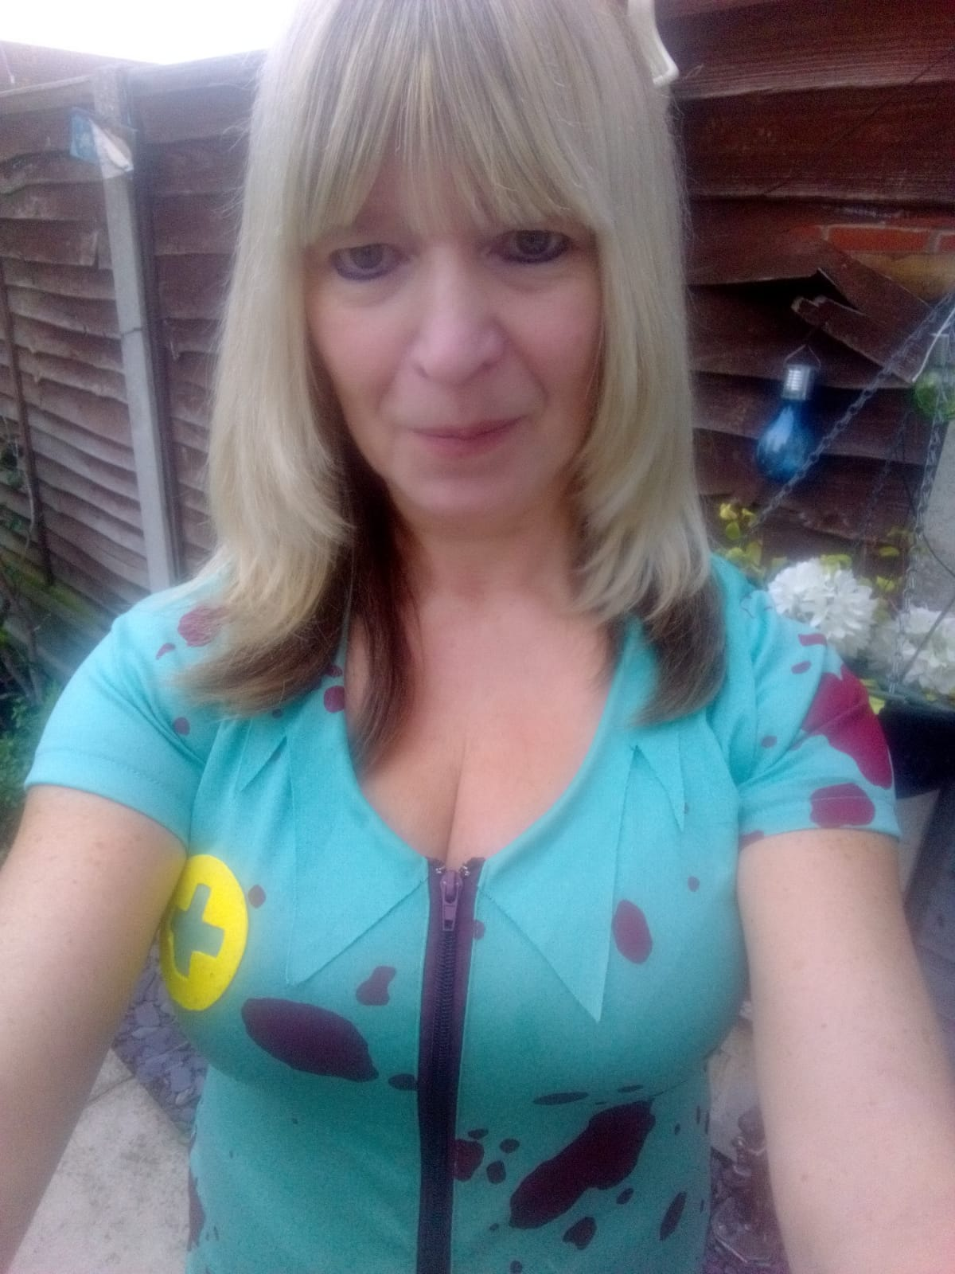

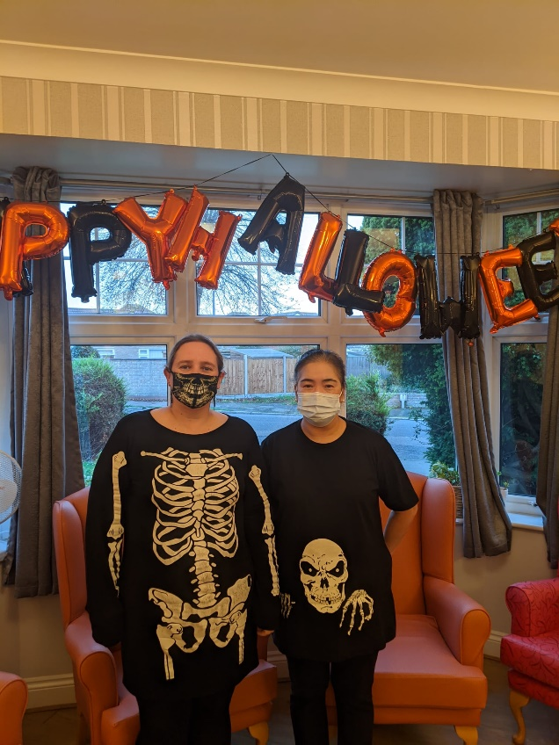

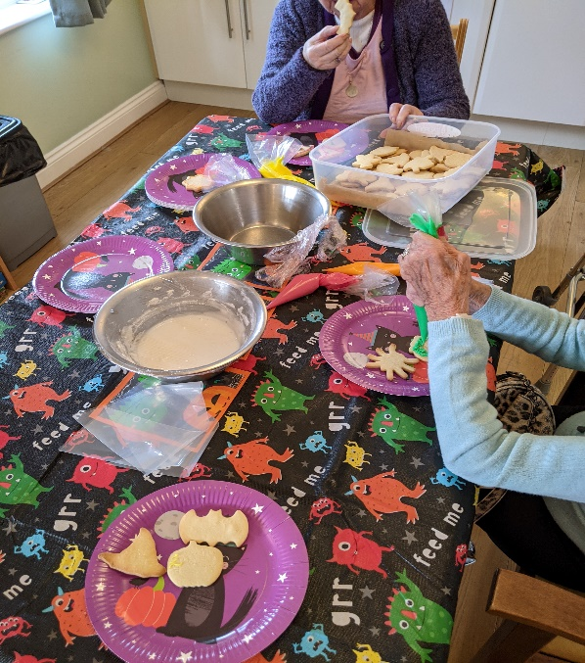

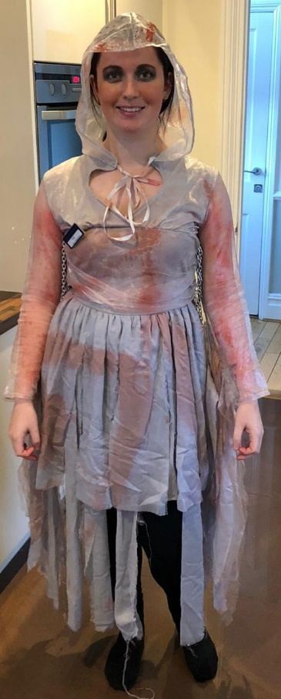

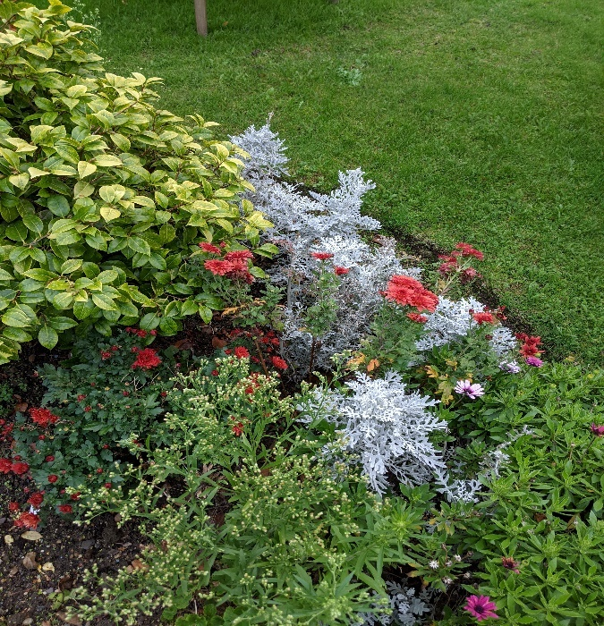The coming month…

* One-to-one garden walks, tea outdoors
* ‘Getting to know one another’
* Mobility workouts
* 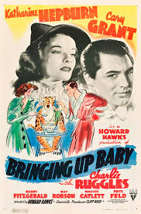Remembrance Day arts & crafts
* Movie Nights
* Games Afternoons
* Karaoke
* 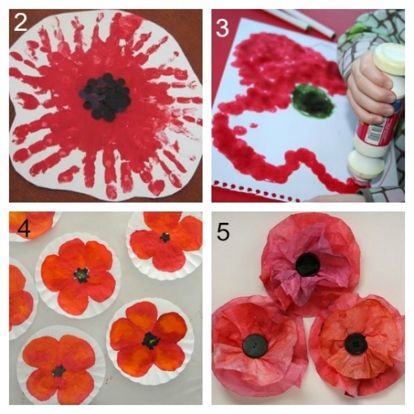Manicure  
    
  Suggestion Box:

What activities would you like to do?

November Birthday’s –   
Residents

Hilda 21st

  
  
  
  
  
  
  
  
  
  
  
  
  
  
  
  
  
November’s Birth Stones are…

Wendy 28th

Raymond 28th

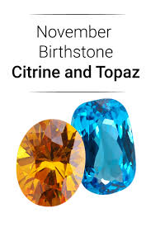Topaz & Citrine   
  
  
  
  
  
  
  
Did you know Chrysanthemum is the birth flower of November? It stands for cheerfulness and love

November Birthday’s –

Staff

Beverley 1st

Angela 1st

Morgan 2nd

Gordon 15th

Rahul

23rd

Catherine 4th



Happy Birthday from all the Staff and Residents at Corner House! We are grateful for each & every one of you!

Employee of the Month

Joanne has been awarded employee of the month for her outstanding support and commitment to both her team and residents.

Joanne is always willing to go the extra mile to ensure that our residents needs are met and that they are well looked after.

Thank you on behalf of all the staff and residents at Corner House!



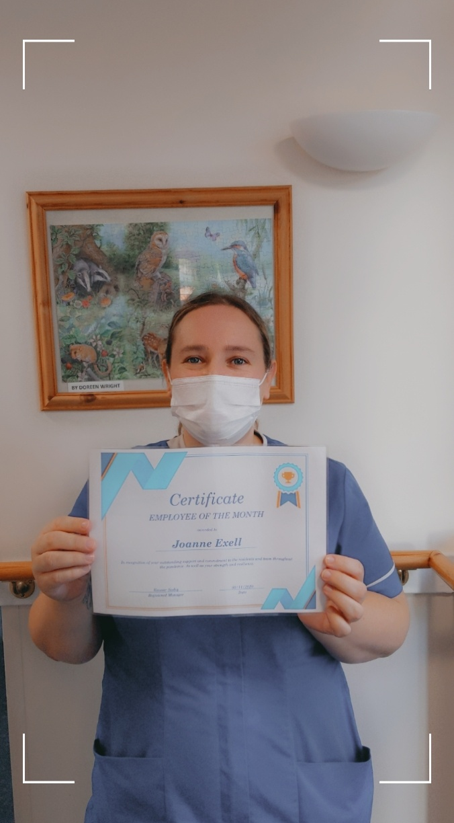

Facts about November

* 27th November 1914

First female police officer begins duty in the UK at Gratham in Lincolnshire

* 11th November 1918

Armistice Day, World War One ended

* 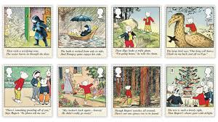8th November 1920 The Daily Express publishes the first Rupert Bear Strip

Cartoon

* 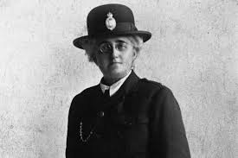

Mrs. Edith Smith

* 3rd November 1957 The first animal was sent into space, a Russian Dog named Laika!

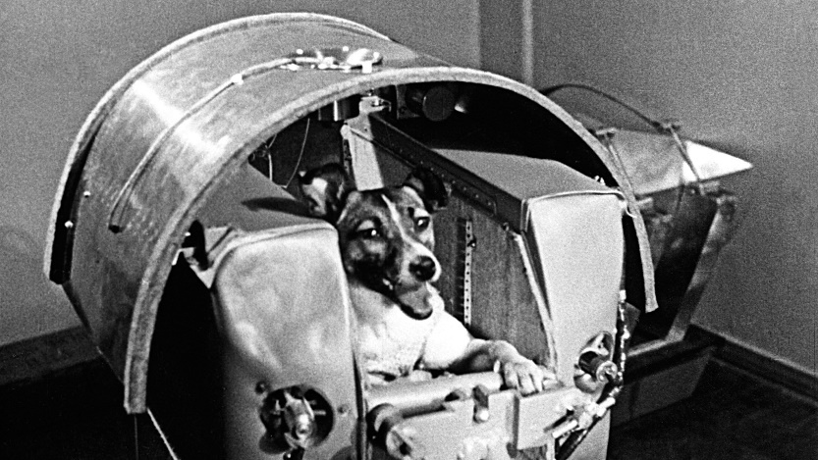

Complete the Wordsearch

Visiting

Due to enhanced restrictions we are currently suspending all visits. This includes visits at the window.

We understand that this is an extremely difficult time, but we are doing all we can to ensure the safety of our residents and staff is at the heart of what we do.

We will continue to facilitate facetime, WhatsApp, Zoom and Skype calls. We have purchased a new

interactive screen to make this accessible as well as interactive tabletops for those residents who are bed bound.

If you would like to arrange a video call, please email

Kausar@cornerhousecare.co.uk

stating the time and date you would like to make the call and we can get this sorted for you.

Complete the activity

