Visiting at Corner House During COVID-19

09/04/2021

Care homes, local health partners, families and residents can work together to make care home visits as safe as possible for everyone. We will work to minimise risks wherever possible to help family and friends spend time together.

The directors and registered manager are responsible for setting the visiting policy and for considering the individual needs of each resident.

Each resident is able to nominate up to 2 named visitors who can come into the care home if they test negative on every visit, wear the right PPE, and follow all infection control measures. Visitors and residents may hold hands, but bear in mind that any contact increases risk. Physical contact like hugging and kissing should not take place.

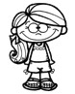
One child may accompany a named visitor during their visit. It is important that any children visiting are able to follow all infection control measures carefully. This will include social distancing, PPE use (children aged 11 and over), and advice on minimising physical contact – as well as being able to follow any other instructions or advice the care home staff might provide. As is the case with visitors of all ages, there should be no close physical contact between children and the residents they are visiting. Children under the age of 3 will not be asked to wear masks, for safety reasons. Children under the age of 11 will not be asked to take a Lateral Flow Test.

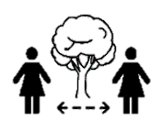
Outdoor visits will be an option when the weather permits. Social distancing, PPE and good hand hygiene are still very important.

Visits in exceptional circumstances, such as end of life, will always be supported and special arrangements are available.

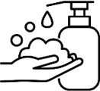
It is essential that visiting is supported by good infection control – this includes social distancing, PPE and hand hygiene while in and around the care home – including during the visit itself.

If there is a COVID-19 outbreak in the care home, unfortunately visiting will have to stop until the outbreak is over. This is to protect vulnerable residents, staff, and visitors.

