|  |  |
| --- | --- |
|  | The Bric-a-Brac |

Residents Newsletter APRIL 2021

Corner House Care Home



Welcome to the **April newsletter**. Happy Easter to everyone!!  
VISITORS We are delighted to welcome back visitors to the home! We have missed not being able to see friends and relatives at Corner House, but with restrictions lifting slightly, we are slowly getting back a little bit of normality. Please see our Visiting Procedures in this newsletter for your information.

We are lucky to have beautiful gardens and ‘Visiting Pod’ ready for these special visits!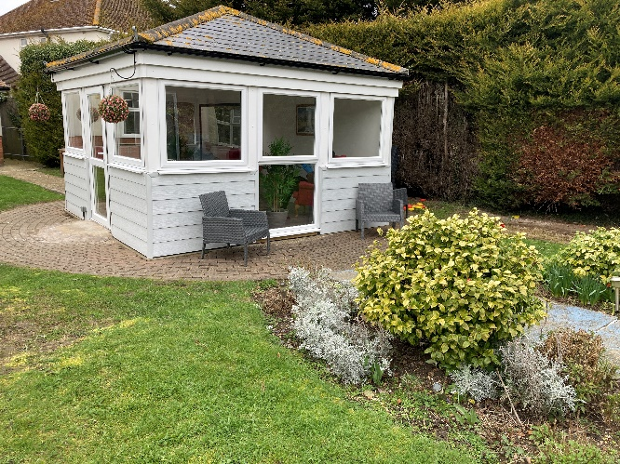

So Easter is very early this year! Good Friday 2nd April

Easter Sunday 4th April

Easter Monday 5th April

And apart from Easter (and lots of Chocolates) – The month of April has much to offer!!

* Earth Day: 22nd April
* St Georges Day: 23rd April
* National Shakespeare Day : 23rd April
* International Jazz Day : 30th April

St Georges Day

How is St. George’s Day celebrated?

In times gone by, people used to wear a red rose in their lapels to celebrate St. George’s Day. Nowadays, people display the Saint George’s cross flag outside their homes with the hymn Jerusalem sung at church services.

**George's day** may be celebrated with anything English including Morris dancing and Punch and Judy shows. A traditional custom on **St**. **George's day** is fly or adorn the **St**. **George's** Cross flag in some way: pubs in particular can be seen on 23 April festooned with garlands.

**Earth Day** is celebrated on April 22 every year. The **day** aims to raise awareness among masses about climate change and global warming. The **day** inspires to act towards the protection of the environment and focus on the need for conservation. **Earth Day** is recognised as the largest civic event in the world

What is Shakespeare Day?

Celebrate the birth of arguably England’s greatest playwright on 23rd April 2021.

Although the actual birth date of William Shakespeare remains unknown, it is most commonly thought to be 23rd April 1564.

Shakespeare was born in Stratford-upon-Avon and died on 23rd April 1616 at the age of 52.

Have a go at the Shakespeare Word Search, at the end of the newsletter!!



3rd April

Irene

20th April

Howard

Enjoy your Special Day!!!

Babies born in April will have either **Aries** (represented by the ram) or **Taurus** (the bull) as their zodiac sign. **Aries** are known for being fiery, passionate go-getters, while those born under **Taurus** are thought to be dependable, sensible, and have a taste for the finer things in life.



*April Activities*

*Come and join in the fun!!*

Easter Arts & Crafts

Easter Sun: Egg Hunt

Sweet Cone making

Dress up for Easter

Lets make some happy memories…..



What does Corner House Do well?

What needs improvement? Do you have Suggestions? Want to Share?

Please, Don’t be shy – We want to hear your views!!

You may not realise it, but Residents, Families and Friends views are valued feedback, which can only help us to meet our resident’s needs and improve.

We want to provide the best Care in the safe, comfortable and stimulating environment.

You may have seen something on the TV or a magazine that has inspired you. Feel free to pass on any ideas or suggestions.

*Resident’s Jewellery and Valuables*

*Just a quick reminder. We understand that residents love to have sentimental items of jewellery and keepsakes, with them at all times.*

*We must, however, stress that Corner House cannot take responsibility for ensuring the safety of these items and our insurance will not cover the cost of lost items.*

*If you need advice please speak to Jo or Kausar.*

**Updated Visiting Procedures**

**Visiting is an essential part of our Ethos and Culture here at Corner House Care Home. Its such a boost for us all and helps maintain our health and wellbeing.**

In order to comply with Government Guidelines, we have a strict procedure and this is what we ask.

1. Each Resident has a single nominated visitor, who will be able to visit by appointment.
2. These visitors must consent to a Lateral Flow Test and complete a health declaration, before each visit goes ahead.
3. PPE (Personal Protective Equipment) must be worn during the visit. Infection control measure must be adhered to and you will be guided by staff on this matter.
4. Visitors and Residents may hold hands but hugging and kisses – sorry they are not allowed. Physical contact must be minimal for the safety of our residents.
5. All Visitors must comply with these rules.

We thank you again for helping us to control the risk of Transmission during this difficult time. We are here to help and if you have any questions regarding visitation then please do ask.

Procedures will be updated according to Government Guidance.

Welcome Back…..



And thank you to:

Jenny Tucker

Special thanks go to Jenny, who is part of our amazing Domestic Team. Jenny goes that extra mile to keep resident’s rooms and communal areas looking beautifully clean and tidy and we all appreciate Jenny’s hard work. Thank You.





Did you know:

The idea for the Easter Bunny began in Germany and was originally a hare. Easter was named after the Anglo-Saxon goddess, Eastre, whose symblols were the egg and the hare.

Most people eat the ears of a chocolate bunny first

The world’s largest Easter Egg Hunt consisted of 501,000 eggs that were searched for by 9753 children at the Cypress Gardens Adventure Park in Winter Haven, Florida.

The largest Chocolate Egg was created in Tosca, Italy. It weighed 15,873 llbs 4.48 oz and had a circumference of 64ft, 3.65 ins at its widest point.

In some countries, other animals bring Easter Eggs:

Switzerland: a Cuckoo, Westphalia: a fox, Australia: a Bilby

More than 90 million chocolate Easter Bunnies are manufactured each year.

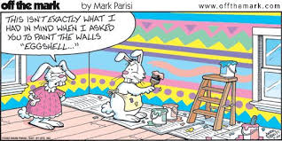

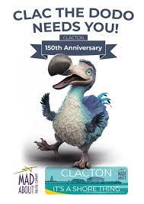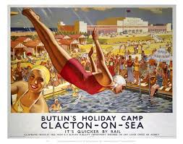

So we need your help ALL!!

To Celebrate the Towns 150th Year – 2021, the Mad About Theatre Company and the ‘Clac the Dodo’ would love your memories of our lovely town - Clacton-on-Sea.

Please have a look and a think – Have you any photos or piece of writing, art, a doodle, a memory, a poem to keep our town vibrant and alive and keep that Dodo from the shore!!

Please either send/bring into the home and we will share with the above. Or if you prefer send direct to:

The Mad about the Theatre Company

46, Vista Road. Clacton-on-Sea / Email:

Facebook madaboutthetheatreco.

Closing date 30th June!

*Watch out for the Musical comedy ‘Clacton Sunny Side Up The Return of the Dodo. Call the Theatre co. on 07709315510, for more details.*

COME ON -LETS CONTRIBUTE! DIG DEEP, WE WOULD LOVE TO HEAR YOUR STORIES/MEMORIES OF SEASIDE FUN.

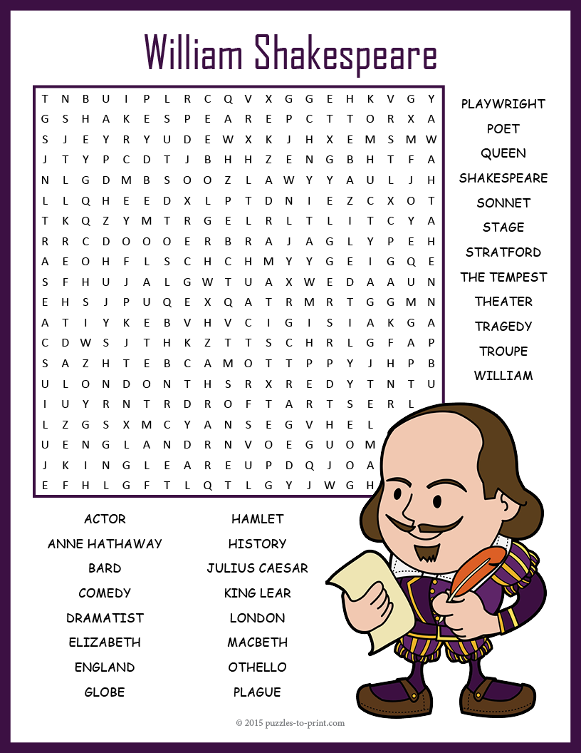

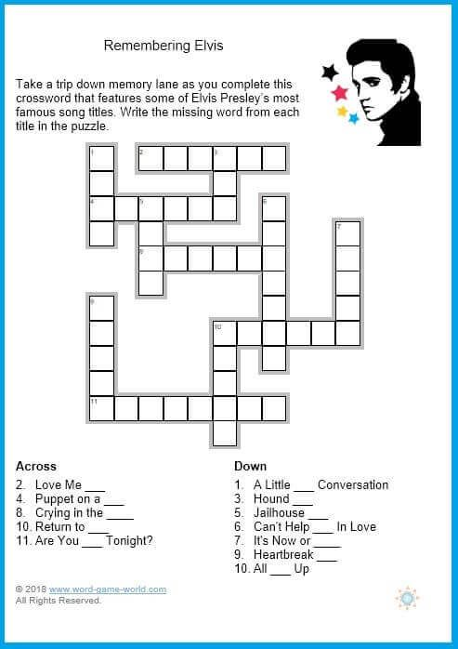

"It's Now or Never" is a song recorded by **Elvis Presley** and released as a single in 1960. The song is the best-selling single by **Presley** (20 million copies), and one of the best-selling singles of all time. Clue for you.